Prototype FPS Controller Documentation

Current Controller prototype to test in my unity fps game.
Parts:
- Breadboard
- Jumper Wires
- Pi Pico WH
- MPU 6050
- Buttons
- Soldering Iron
- Solder Alloy
Ordered from the PiHut website and Amazon;
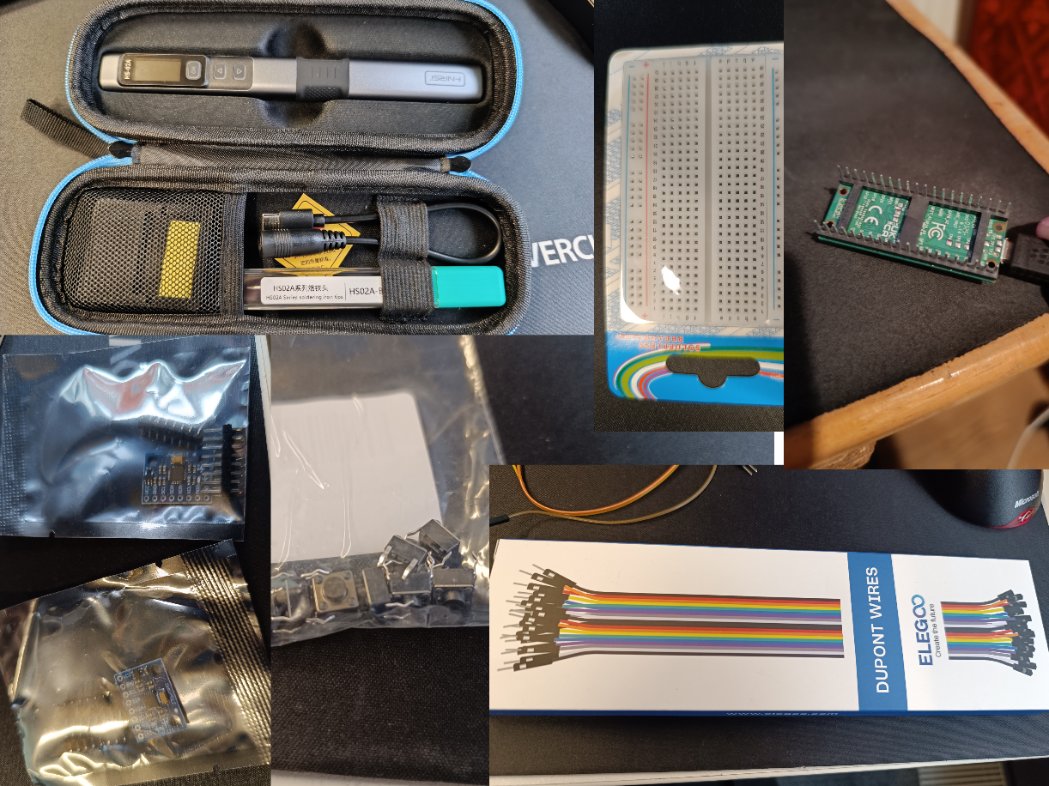
Figure 1: All the parts ordered

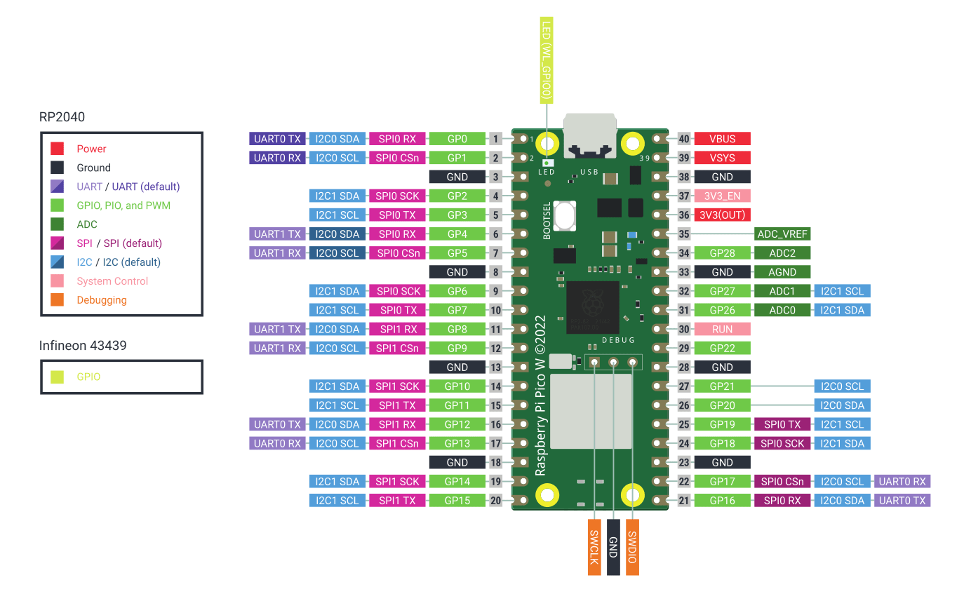
Figure 2: Pico W H System

Placed the Pico W H and soldered the MPU6050 to the pins and attached it to the breadboard. 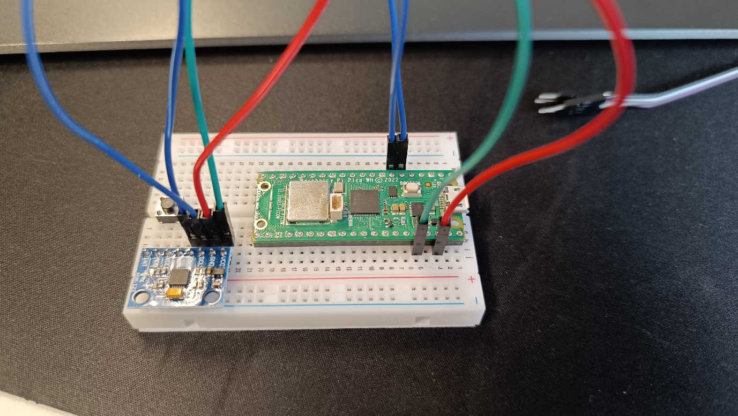
Figure 3: Current Controller Prototype

